**General Chemistry LabII-1112L**

# Lab Report#___11___

Andrew Kalathra, Department of Chemistry and Biochemistry, Lamar University, Beaumont TX 77710

**Title- Entropy and Free Energy1**

**Objective**- Find and explore the relationship between entropy, enthalpy, and free energy.

**Procedure-**

* 1. First, we set up and got our primary materials. This included setting up our heat probe.
  2. Next, we measured out close to 3 g of urea, and separately (in the Styrofoam cup) we measured and weighed 50 mL of deionized water and recorded its initial temperature.
  3. We then added the urea into the Styrofoam cup, mixed it with the probe, and recorded it final temperature. This concluded our first experiment.
  4. Next, we measured out close to 2 g of urea and put it into a graduated cylinder. This graduated cylinder went into a water bath to keep the temperature of the reaction relatively constant.
  5. We then slowly added water (except for 3 mL where we just added it quickly) while continuously mixing the solution. At a certain point, the solute was completely dissolved, so we recorded the temperature and volume of the solution and concluded our experiment.

**Data and Results**

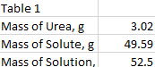

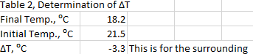

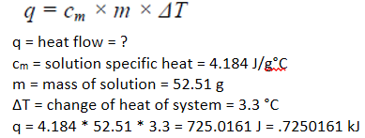

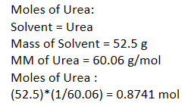

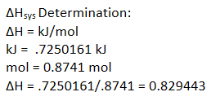

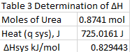

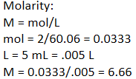



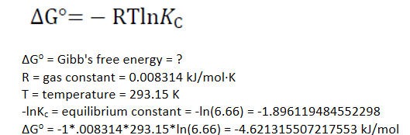

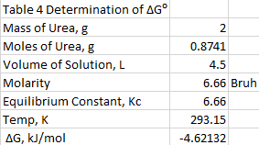

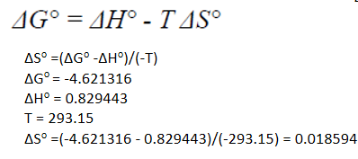

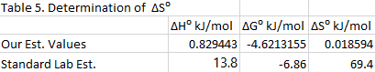

**Conclusions**

In conclusion, I got to calculate the enthalpy and the free energy of the reaction of urea and water. I then got to use those values to calculate the entropy. Overall, we got to explore how entropy, enthalpy, free energy, and spontaneity are all related. Our values were not close to the lab estimates, and I would blame that on myself for inaccurate measures of the initial and final temperature, the final volume of the solution, and the actual mass of the solute, urea. Finally, if I had done this lab over again, I would have made sure to find the inaccurate variables above and would try finding more accurate tubes, instead of guessing in between.

**Key Questions-**

**1. In the model of heat flow above, which is the exothermic process and which is the endothermic process? -**

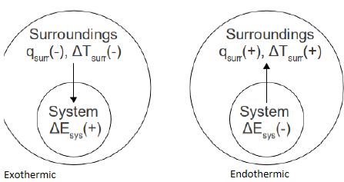

**2. If heat change were monitored with a thermometer, would the recorded temperature change be that of the surroundings or of the system? (Hint: is the thermometer part of the system or the surroundings?) -** Surrounding

**3. As seen from the perspective of a system, heat flowing into the system should have what sign? As seen from the perspective of the surroundings, heat flowing into the system should have what sign? Based on the definition of ΔH which sign should be used? -** A) +, B) -, C) -

**4. What is the dominant intermolecular force holding solid urea together? -** Hydrogen Bonding

**5. Based on your team's answer above, what would be a good solvent to use in this determination? Why did your team choose this solvent? -** Water, it is also polar, and like dissolves like.

**6. What is the molecular mass of urea? -** 60.06 g/mol

**7. Was the dissolution of urea endothermic or exothermic? Should qsys be a positive or a negative value? Was the heat flow your team calculated for the system (qsys) or for the surroundings (qsurr)? Record the correct sign of qsys in Table 3. -** A) exothermic, heat flowed onto the system, B) +, C) qsurr

**8. For the dissolution reaction of urea, write in the state labels for the products and the reactants based on what your team has observed so far in this laboratory. -** 

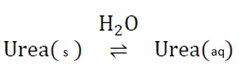

**H2O**

**Urea( )⇌ Urea( )**

**9. Based on the chemical equation for dissolving urea above, write a formula for the equilibrium constant, KC. Have your instructor or TA review this equation, it is critical for analyzing the experimental data. -**



**10. What value of R should your team use to calculate ΔG in units of kJ/mol: 0.08206 L·atm/mol·K, 8.314 J/mol·K, or 0.008314 kJ/mol·K? -** It has kJ, the value we calculated for before.

**11. Does your team think that the dissolution of urea in water is spontaneous or not? What is your team's evidence? -** It is spontaneous because it started to dissolve automatically when we kept the urea in the water, even though we still had to mix it to help it a little after some had already dissolved. Also, we had a negative Δ G, and the question below states it.

**12. Based on the fact that the dissolution of urea is spontaneous, how does your team think the sign (positive or negative) of the ΔG° relates to the spontaneity of a reaction? -** Reactions are spontaneous when ΔG° is negative.

**13. On a molecular level, did the distribution of microstates in the system increase or decrease during the dissolution of urea? Why did your team choose that answer? -** It would increase the dissolution, that is because an increase in microstates would be an increase in disorder, and reactions are mostly more favored toward the side with more disorder.

**14. Based on your team's answer above, should the entropy change of urea dissolving in water be positive or negative? -** Positive

**15. What effect should temperature have on entropy? Explain why on a molecular level. -** It would increase the entropy because it would create a more mixed mixture, creating more of the solution to have multiple microstates, therefore increasing the entropy.

**16. Were your team's results in good agreement with the common values? If not how and why did they differ? -** The values given to me are not even close to my team values, and I thought that entropy is usually in between 0 and 1. My values most likely differ by a lot because calculation errors.

**Outside of lab, for the following questions 17-20, consider:**

**ΔG° = ΔH° - T ΔS°**

**17. If a reaction occurs that is exothermic and the entropy of the system increases, would the ΔG° be positive or negative? Would that reaction be spontaneous or non-spontaneous?** - Negative, it would be spontaneous.

**18. If a reaction occurs that is endothermic and the entropy of the system actually decreases, would the ΔG° be positive or negative? Would that reaction be spontaneous or non-spontaneous?** - Positive, it would be nonspontaneous.

**19. If a reaction occurs that is endothermic but the entropy of the system increases, why does you team need actual values of ΔH° and ΔS° to predict if the reaction would be spontaneous or non-spontaneous?** - The value of ΔG would not be determined by just knowing if they are positive or negative because one value could have a larger magnitude and make ΔG either positive or negative.

**20. For a reaction, if entropy is positive and the enthalpy is positive what must be done to cause the reaction to occur?** - You must decrease the temperature so the second term of the reaction decreases, increasing ΔG.

* Do not forget to attach the signed lab work-out

